NAME: MUNAZA MUNIR
CONTACT NO: 03220147287
EMAIL: 70146760@student.uol.edu.pk
- Title: Playwright Web Automation Testing Report
- Internship: SQA Internship – Week 03 Task 1
- Submitted By: Munaza Munir
- University: The University of Lahore
- Date: 22 July 2026

1. Objective
The objective of this task was to perform automated testing on my personal portfolio website using Playwright. The project demonstrates browser automation, UI verification, form validation, assertions, and report generation using the Page Object Model (POM).

2. Tools Used
Tool | Purpose
Visual Studio Code | Code Editor
Playwright | Automation Testing Framework
JavaScript | Test Script Development
Node.js | Runtime Environment
Live Server | Running the Website
Google Chrome | Test Execution
Mozilla Firefox | Cross-browser Testing

3. Project Structure
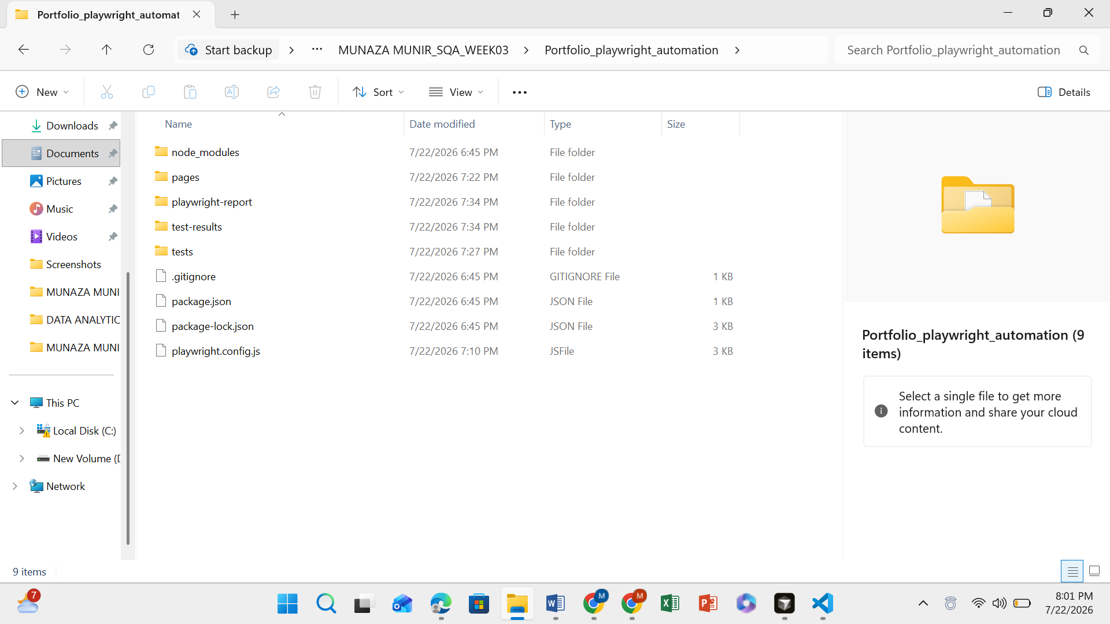

4. Test Scenarios
Test Case | Description | Status
TC01 | Verify Website Title | ✅ Passed
TC02 | Verify Hero Section | ✅ Passed
TC03 | Verify Navigation to Contact Section | ✅ Passed
TC04 | Verify Valid Contact Form Submission | ✅ Passed
TC05 | Verify Invalid Email Validation | ✅ Passed

5. Execution Process
The automation tests were executed using Playwright on Chromium and Firefox browsers. The portfolio website was hosted locally using Live Server. All test cases executed successfully, verifying navigation, page title, user interface elements, and contact form validation.

6. Test Results
- Screenshot of terminal after running:
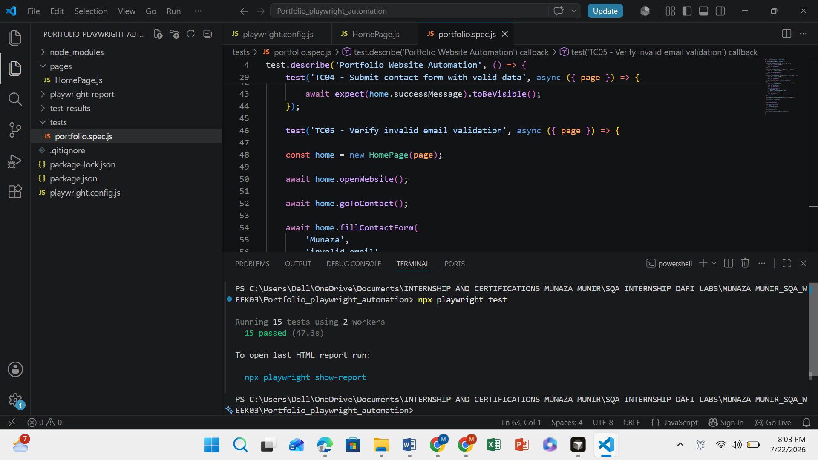
- Screenshot of the Playwright HTML Report showing all tests passed.
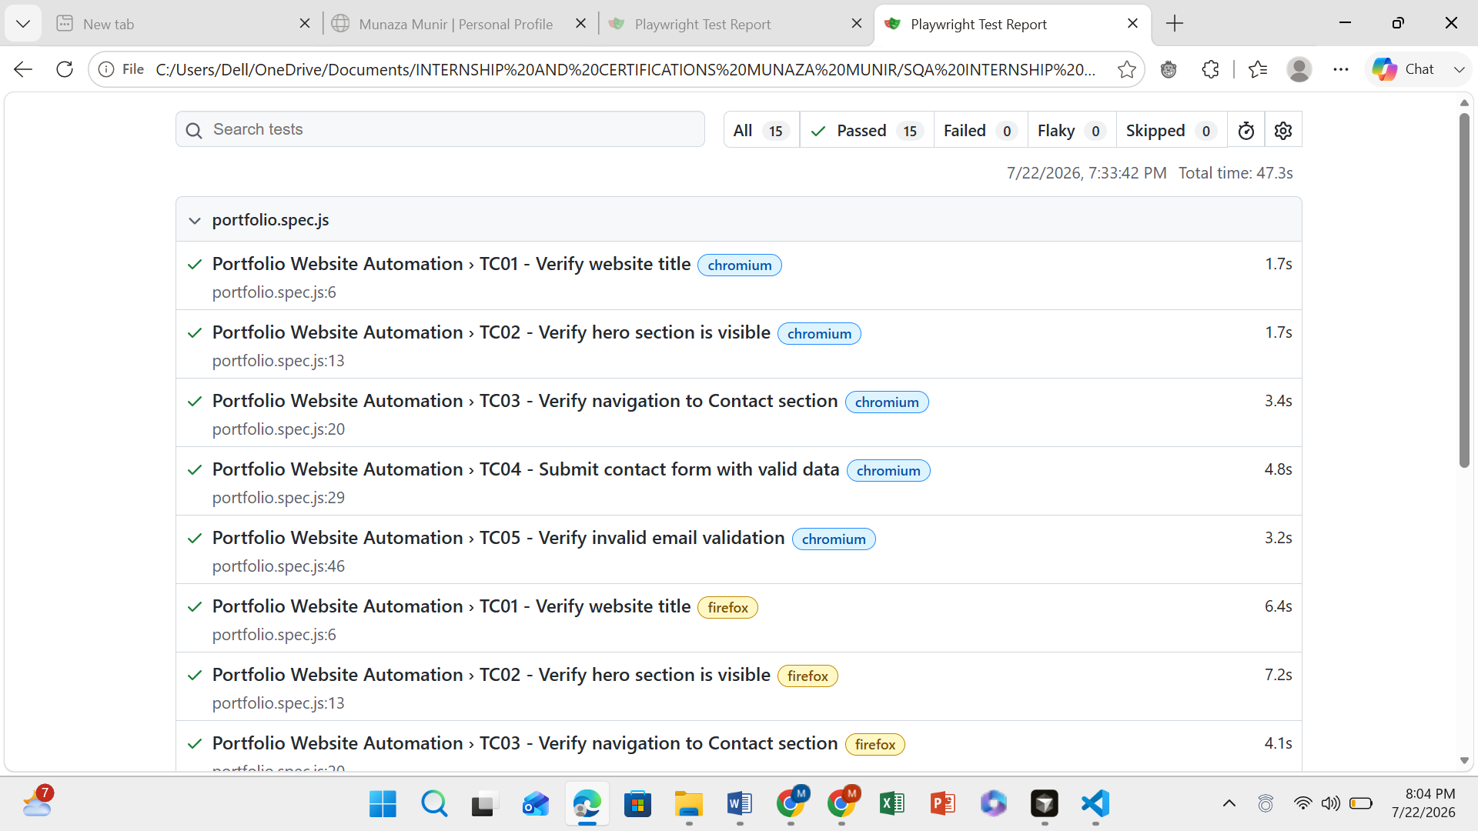

7. Features Implemented
- Playwright Automation
- Page Object Model (POM)
- Assertions
- Form Validation
- Cross-Browser Testing
- HTML Report Generation
- Screenshot and Video Support

8. Conclusion
This task provided practical experience in automated web testing using Playwright. I successfully created an automation framework based on the Page Object Model, executed automated test cases on multiple browsers, validated website functionality, and generated an HTML report. The project improved my understanding of browser automation, assertions, test organization, and software quality assurance practices.

